**Project Report**

[**https://thenewboston.com/videos.php?cat=57**](https://thenewboston.com/videos.php?cat=57)

**Group Members (5 People):**

**Javier Rodriguez 900250447**

**Scott Murray**

**Scott Blick**

**Ahmed Shogar**

**Thanh**

**Requirements:**

* Login window for users and administrators
* Two separate GUIs/Classes for user and administrators
* Databases for login information, student information, *courses??*
* Courses objects
  + Course Name
  + Class ID???
  + Exam Scores
  + Current Grade
* Student object
  + Name
  + ID
  + Courses objects
  + Calculate GPA function
* User Permissions
  + Login
  + View classes
  + Calculate GPA
* Admin Permissions
  + Login
  + View courses
  + View/edit student information
  + Add/delete students
  + Add/delete courses

**Analysis:**

**Team Model:**

**Life Cycle Model:**

* **Rapid Prototyping**
  + **To build a foundation for everyone to work off of**
  + **GUI development**

**UML Diagrams:**

**Database:**

**GUI:**

* 1. Analysis

Based on the requirements, analyze the software and give a planning. Note, use the analysis strategies studied in the lectures to produce necessary artifacts of analysis.

* 1. System Development Life Cycle

Apply the knowledge you learned from the class, apply 2D life cycle models on the project. Select the suitable life cycle models and present your reasons.

* 1. Team Work

Select a team model as presented in the chapter 4. Describe your team organization and clarify each team member’s responsibility. Since this is a team project, the collaboration among team members is required. Corresponding artifacts are required to be submitted.

* 1. Apply UML Method

Through requirements and analysis of the project, draw out necessary UML diagrams in the project.

* 1. Database

Database is critical for all businesses. A good database does not allow any form of anomalies and stores only relevant information in an ordered manner. If a database has anomalies, it is affecting the efficiency and data integrity. For example, delete anomaly arise upon the deletion of a row which also forces other useful data to be lost. In this project, you need to design a database, tables, and fields to build this software system. Include the necessary artifacts related to database in the project.

* 1. Graphical User Interface (GUI)

You are expected to design simple GUI in the project. The following figure present several sample GUI. Open source GUI development platforms (e.g. Qt) are recommended. Note this GUI is not complete, because no text on the buttons and other widgets.

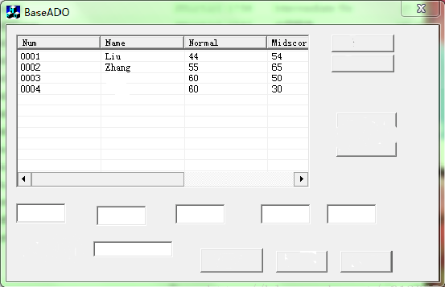 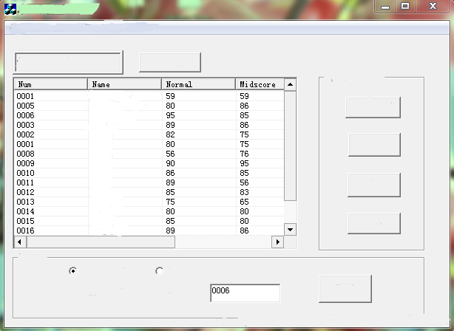 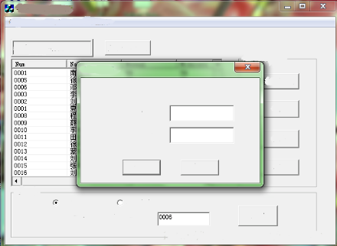

1. **Project Report and Items**

The final grade of the project will be evaluated comprehensively based on the completeness of the all submitted items. During and after the project, the following items are expected to be submitted.

* 1. Submit a project report to answer the following questions?

How many members are you in your team? List all team members.

What type of team model is used in the project (chapter 4)?

Paste all UML diagrams you used in the project. Some important diagram are expected to be included like architecture diagram, use case diagram, class diagram, and so forth.

* 1. Presentation in the classroom at the end of the semester. Each team leader and members are expected to present your work at the end of the semester.
  2. Submit all artifacts you used in the project. These artifacts include source code, version control documentation, test cases, database files, and so forth.